PCC Hoarding Forum referral
Email to: Julia.potkins@peterborough.gov.uk
Name: |  |  |  | DOB:
Mosaic Number: |  |  |  | Client Consent |  | Yes/No
GP Surgery: |  |  |  | Working Fire Alarms |  | Yes/No
Name and contact details of person making referral
Names and details of other in the property
Address
Tenancy type and provider
Professionals / services involved
Agency |  |  | Name |  | Involvement / Support
Details / history of the case
Risk information
(Please consider - Self neglect, risk to others, structural, fire, pets)
Any questions you wish to discuss.
Clutter index – using the images below at what stage of hoarding do you feel the person is at and if applicable describe differences between rooms.

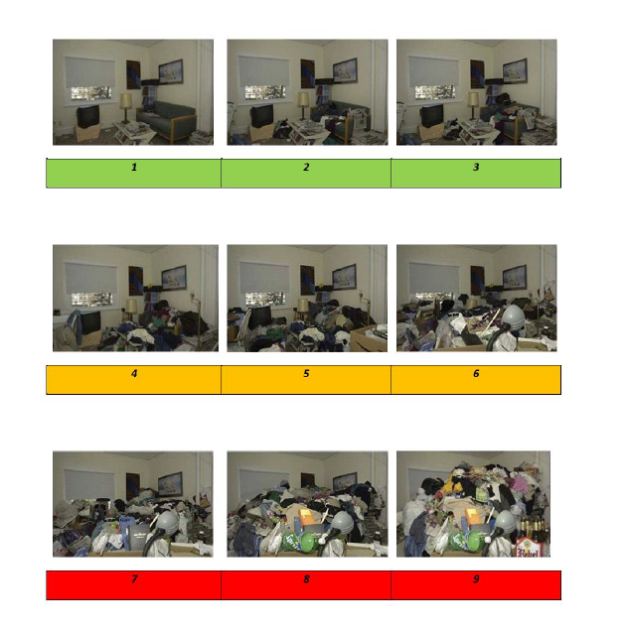

Completed forms to be returned to: julia.potkins@peterborough.gov.uk

